**NOIDA INSTITUTE OF ENGINEERING AND TECHNOLOGY**



**MINI PROJECT (KCS - 354)**

**Department of Computer Science and Engineering**

**Submitted by: Submitted to:**

***Dev Raj Gaur Ms. Shweta Mayor Sabharwal***

***Ayushi Samanta***

***Dev Vikram Singh***

SYNOPSIS

ON

RESUME PORTFOLIO

**CERTIFICATE**

This is to certify that the Mini Project report entitled “Resume Portfolio” is a record of work done by the following students:

STUDENTS NAME: ROLL NUMBER:

Ayushi Samanta (1901330100082)

Dev Raj Gaur (1901330100092)

Dev Vikram Singh (1901330100093)

This work is done under our supervision and guidance during the academic year of 2020-21. This report is submitted to the **Noida Institute of Engineering & Technology**, **Greater Noida** for partial fulfilment for the degree of **B.TECH. (COMPUTER SCIENCE AND ENGINEERING)** of **Dr. A.P.J Abdul Kalam Technical University**, Lucknow, Uttar Pradesh, India.

We wish him all the best for all the endeavours

**Signature of Guide:**

Ms. Shweta Mayor Sabharwal

(Assistant Professor)

**ACKNOWLEDGEMENT**

I would like to place on my record my deep sense of gratitude to **Ms. Shweta Mayor** (Assistant Professor) in **Department of Computer Science of Engineering**, **Noida Institute of Engineering & Technology**, Greater Noida, Gautam Budha Nagar, Uttar Pradesh, India for his/her guidance, help and useful suggestions.

I express my sincere gratitude to **Prof. Chandra Shekhar Yadav, HOD(CSE)**, Noida Institute of Engineering and Technology, Greater Noida for his simulating guidance, continuous encouragement and supervision throughout the course of present work.

Date:

**INDEX**

**Certificate**

**Acknowledgement**

|  |  |  |
| --- | --- | --- |
| **S. No.** | **Topic** | **Signature/Remarks** |
| 1. | Introduction |  |
| 2. | Motivation |  |
| 3. | Literature Review |  |
| 4. | Methodology |  |
| 5. | Plan of Work |  |
| 6. | Modules |  |
| 7. | Tools and Techniques Required |  |
| 8. | Project Phase Design |  |
| 9. | Data Flow Diagram (DFD) |  |
| 10. | Project Snapshots |  |
| 11. | Code |  |
| 12. | Future Scope |  |
| 13. | References |  |

**INTRODUCTION**

* Here is a project we developed as Mini Project in Resume Portfolio during our Third Semester. This project is focused on creating a resume portfolio template
* Which can be used by the user to create an eye-catching CV
* Our project provides features for showing your skills in an effective manner

**MOTIVATION**

1. The motivation for doing this project was primarily an interest in undertaking a challenging project in an interesting area of research. The opportunity to learn about a new area of web development which was not covered in lectures.
2. We tried to learn web development in this lock down, and tried to build a project with the help of it.
3. So, we did a little research and got to know about the portfolio which could be really helpful for the students for creating a great resume. So, we have been working on it lately, I think its a good idea to make a project based on we development.

**LITERATURE REVIEW**

The main objective of this project is to create a portfolio template which shows up your resume with all of your skills, achievements, hobbies, etc in the form of a website.

Using this portfolio resume template can be helpful in highlighting your achievements or skills or hobbies which we want to show to the interviewer.

**METHODOLOGY**

SOFTWARE DEVELOPMENT LIFE CYCLE (SDLC)

This project follows the iterative waterfall model.

The iterative waterfall model provides feedback paths from every phase to its preceding phases.

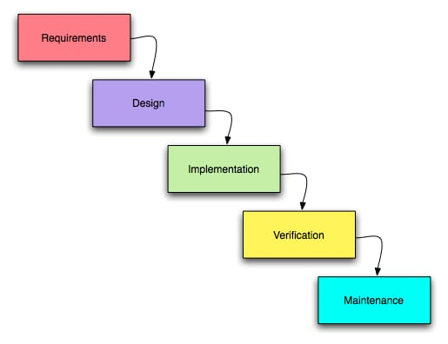

WATERFALL MODEL

When errors are detected at some later phase, these feedback paths allow correcting errors committed by programmers during some phase. The feedback paths allow the phase to be reworked in which errors are committed and these changes are reflected in the later phase.

**PLAN OF WORK**

PERT CHART

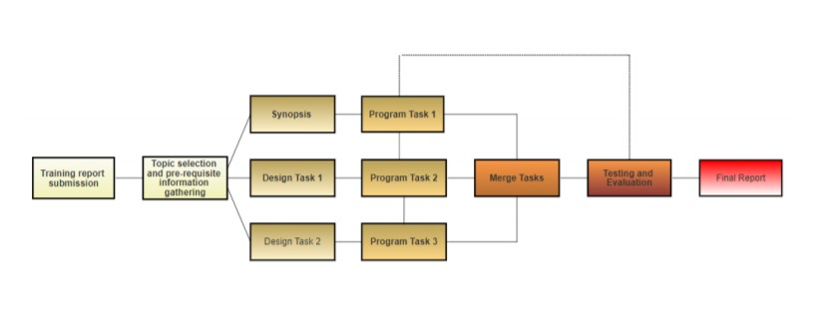

1. Starting from information gathering about the project.
2. Designing the layouts and workflow of the project.
3. Developing it to code.
4. Testing and debugging the code.
5. Finally building the project and exporting it as a webpage.

GANTT CHART

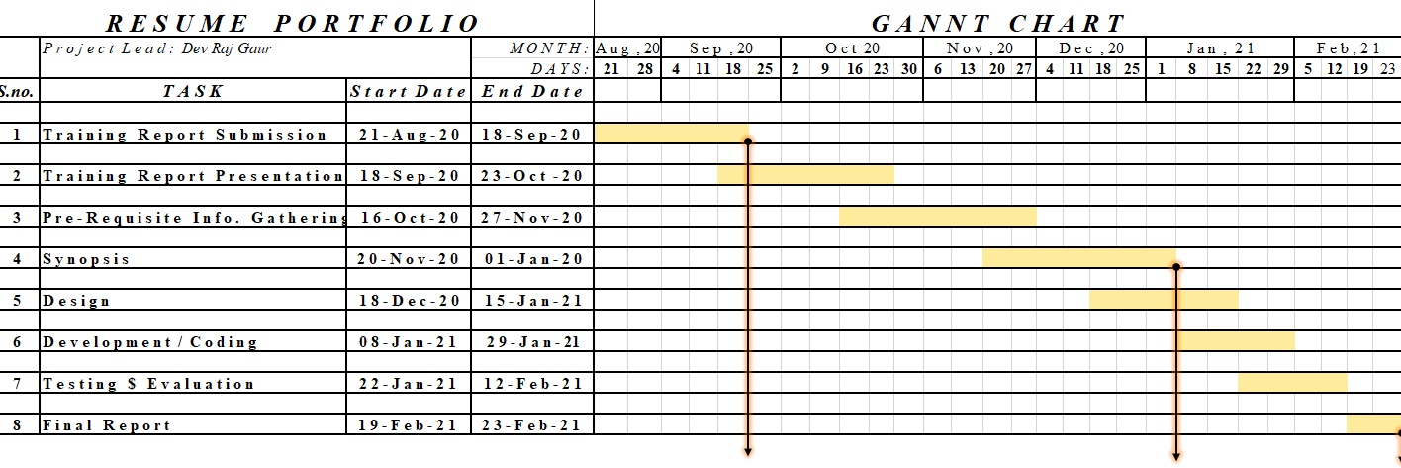

Project report Submission

Synopsis Submission

Training Report Submission

**MODULES**

**TOOLS AND TECHNIQUES REQUIREMENT**

HARDWARE:

Desktop/Laptop

Requirements:

* 4 GB RAM
* 215+ GB ROM
* INTEL i3 5th gen. or any other processor

Software:

* VS Code (to edit the template)
* Any browser to open the page

**PROJECT DESIGN PHASE**

**DATA FLOW DIAGRAM**

A data flow diagram shows the way information flows through a process or system. It includes data inputs and outputs, data stores, and the various subprocesses the data moves through. DFDs are built using standardized symbols and notation to describe various entities and their relationships.

Data flow diagrams visually represent systems and processes that would be hard to describe in a chunk of text. Visualizing each element makes it easy to identify inefficiencies and produce the best possible system.

**Data flow diagram levels**

* Level 0 DFDs, also known as context diagrams, are the most basic data flow diagrams. They provide a broad view that is easily digestible but offers little detail. Level 0 data flow diagrams show a single process node and its connections to external entities.
* Level 1 DFDs are still a general overview, but they go into more detail than a context diagram. In a level 1 data flow diagram, the single process node from the context diagram is broken down into subprocesses.
* Level 2+ DFDs simply break processes down into more detailed subprocesses.

**DFD LEVEL 0**

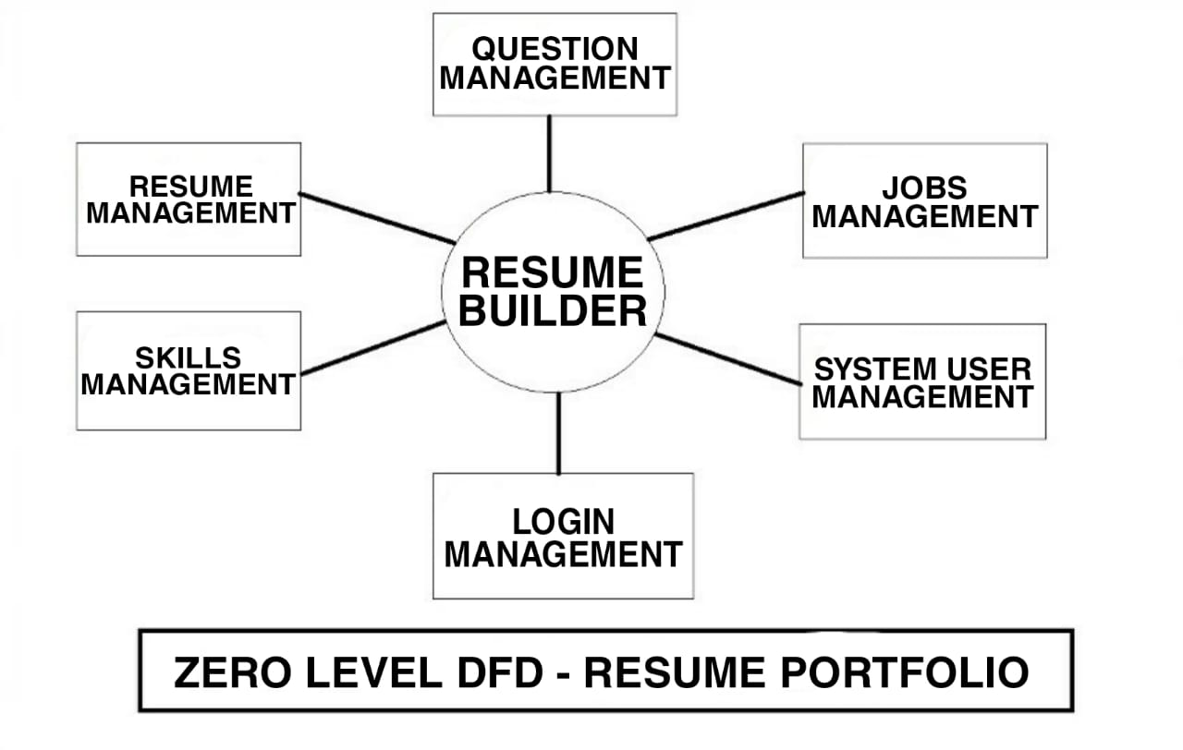

**DFD LEVEL 1**

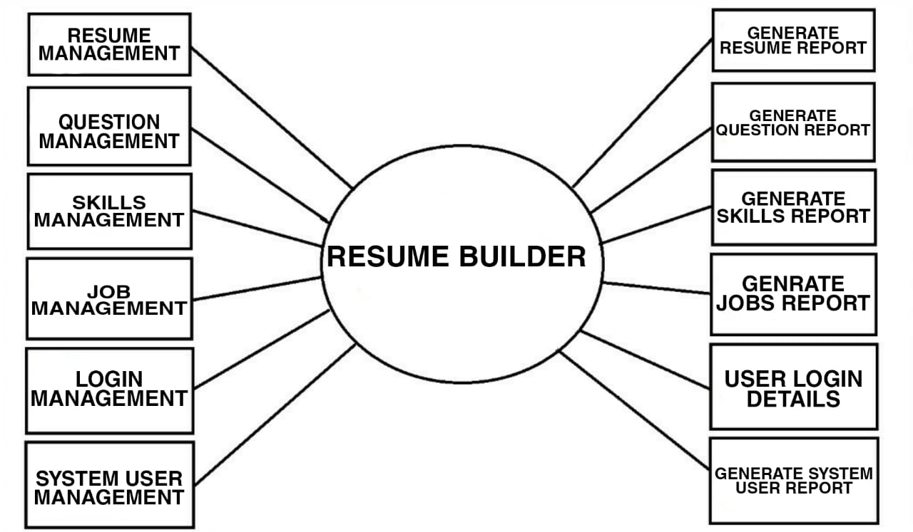

**SANPSHOTS**

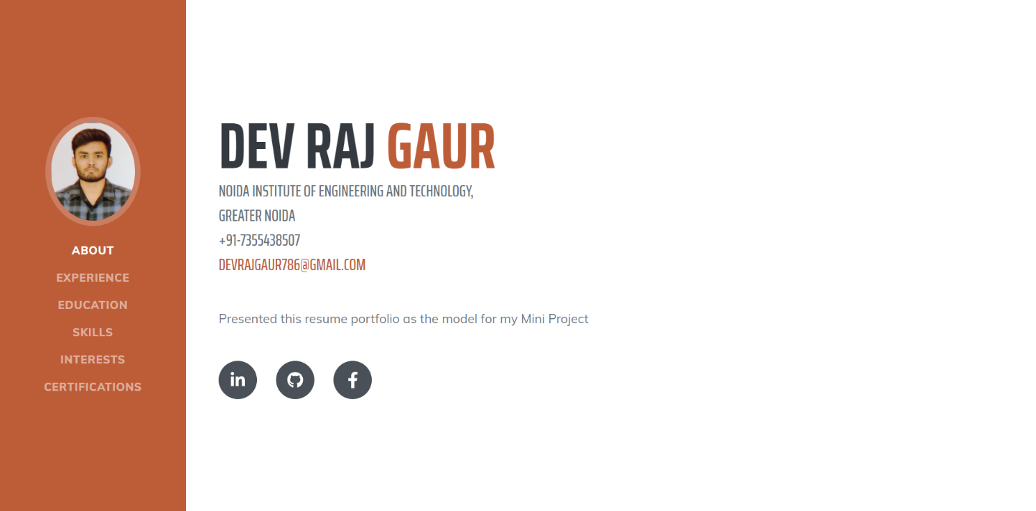 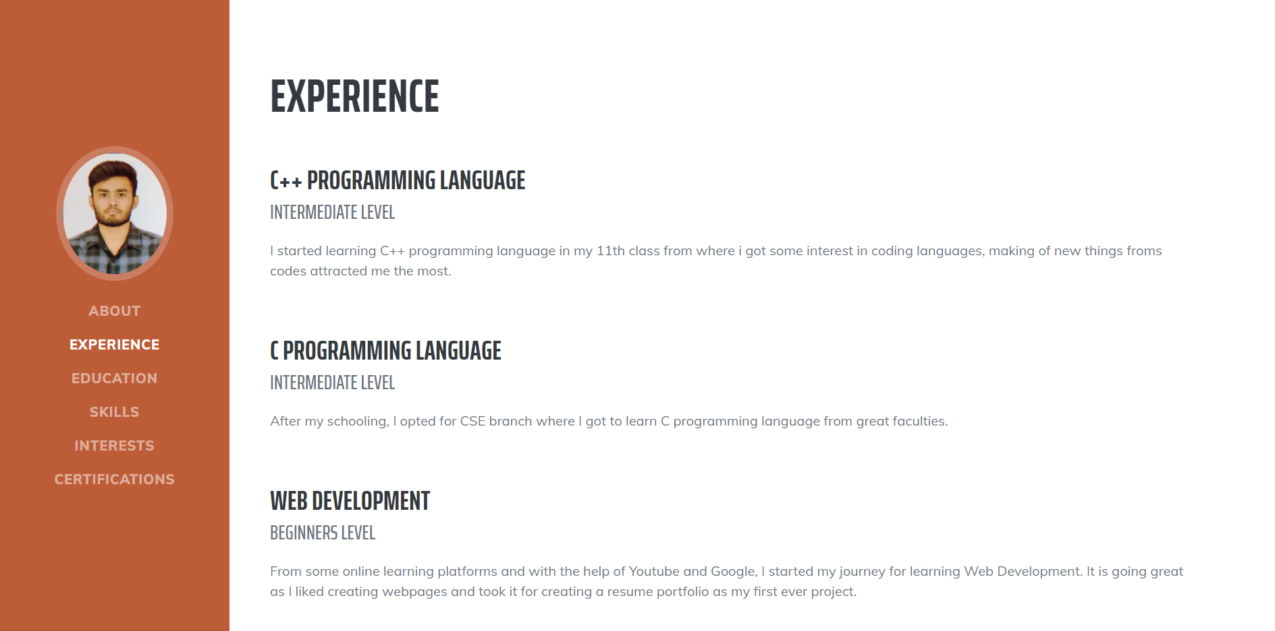 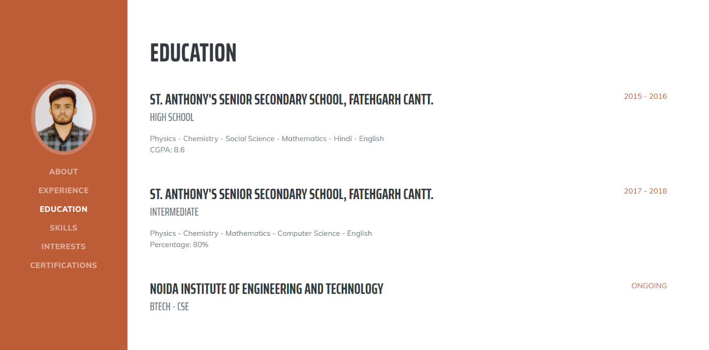 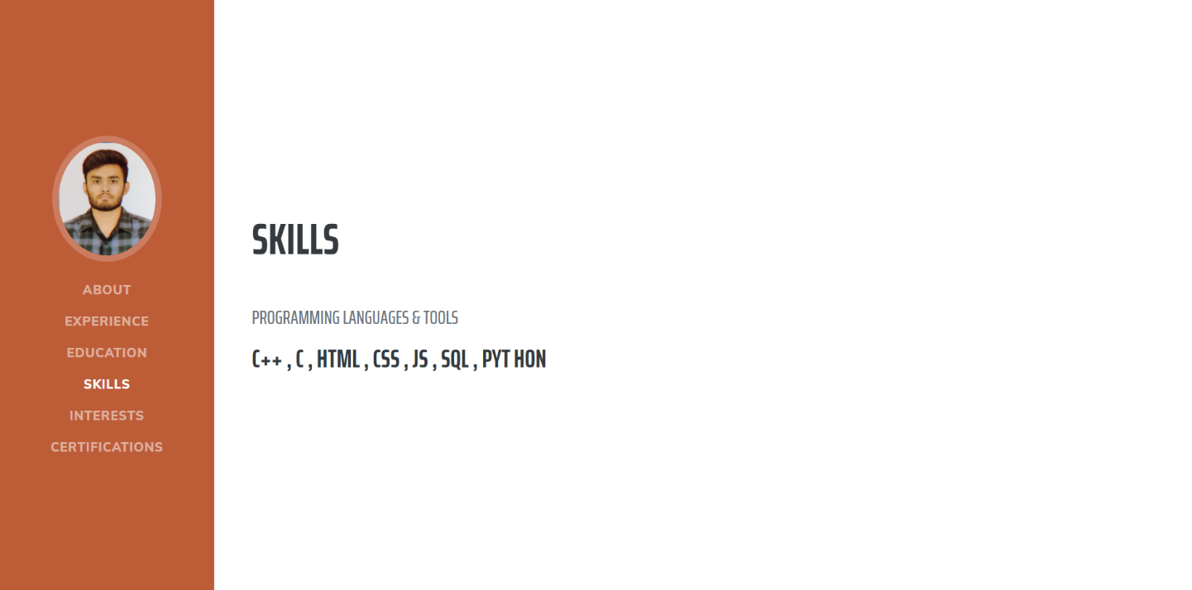 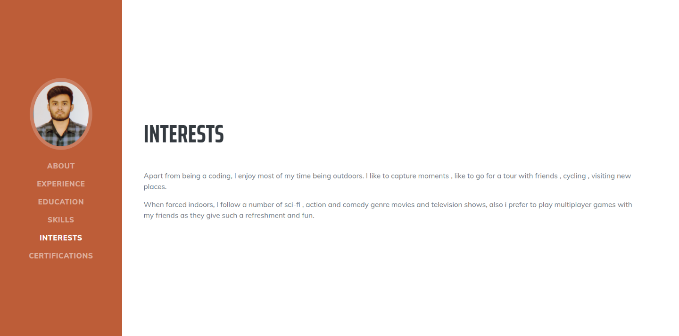 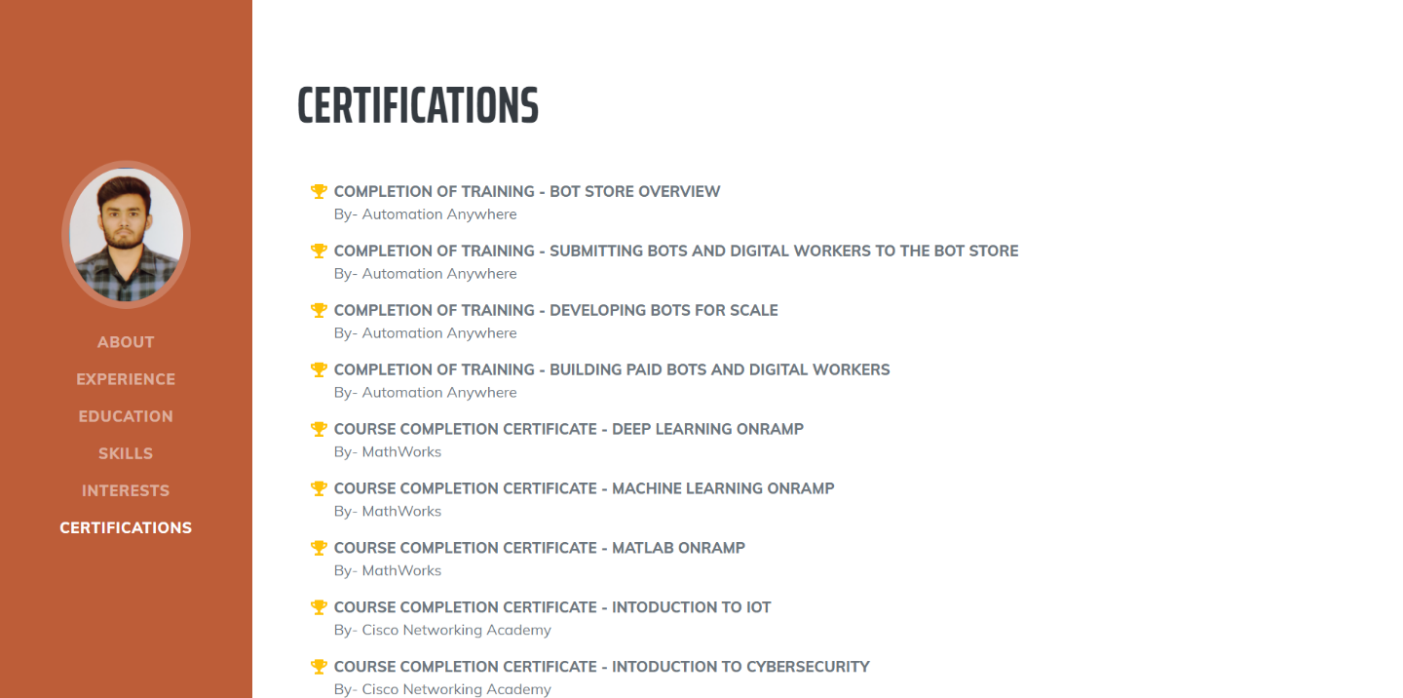

**CODE**

<!DOCTYPE html>

<html lang="en">

<head>

<meta charset="utf-8" />

<meta name="viewport" content="width=device-width, initial-scale=1, shrink-to-fit=no" />

<meta name="description" content="" />

<meta name="author" content="" />

<title>Resume - Portfolio</title>

<link rel="icon" type="image/x-icon" href="assets/img/favicon.ico" />

<!-- Font Awesome icons (free version)-->

<script src="https://use.fontawesome.com/releases/v5.15.1/js/all.js" crossorigin="anonymous"></script>

<!-- Google fonts-->

<link href="https://fonts.googleapis.com/css?family=Saira+Extra+Condensed:500,700" rel="stylesheet" type="text/css" />

<link href="https://fonts.googleapis.com/css?family=Muli:400,400i,800,800i" rel="stylesheet" type="text/css" />

<!-- Core theme CSS (includes Bootstrap)-->

<link href="css/styles.css" rel="stylesheet" />

</head>

<body id="page-top">

<!-- Navigation-->

<nav class="navbar navbar-expand-lg navbar-dark bg-primary fixed-top" id="sideNav">

<a class="navbar-brand js-scroll-trigger" href="#page-top">

<span class="d-block d-lg-none">Dev Raj Gaur</span>

<span class="d-none d-lg-block"><img class="img-fluid img-profile rounded-circle mx-auto mb-2" src="assets/img/profile.jpg" alt="" /></span>

</a>

<button class="navbar-toggler" type="button" data-toggle="collapse" data-target="#navbarSupportedContent" aria-controls="navbarSupportedContent" aria-expanded="false" aria-label="Toggle navigation"><span class="navbar-toggler-icon"></span></button>

<div class="collapse navbar-collapse" id="navbarSupportedContent">

<ul class="navbar-nav">

<li class="nav-item"><a class="nav-link js-scroll-trigger" href="#about">About</a></li>

<li class="nav-item"><a class="nav-link js-scroll-trigger" href="#experience">Experience</a></li>

<li class="nav-item"><a class="nav-link js-scroll-trigger" href="#education">Education</a></li>

<li class="nav-item"><a class="nav-link js-scroll-trigger" href="#skills">Skills</a></li>

<li class="nav-item"><a class="nav-link js-scroll-trigger" href="#interests">Interests</a></li>

<li class="nav-item"><a class="nav-link js-scroll-trigger" href="#awards">Certifications</a></li>

</ul>

</div>

</nav>

<!-- Page Content-->

<div class="container-fluid p-0">

<!-- About-->

<section class="resume-section" id="about">

<div class="resume-section-content">

<h1 class="mb-0">

Dev Raj

<span class="text-primary">Gaur</span>

</h1>

<div class="subheading mb-5">

Noida Institute Of Engineering and Technology,<br>Greater Noida<br>+91-7355438507<br>

<a href="mailto:name@email.com">devrajgaur786@gmail.com</a>

</div>

<p class="lead mb-5">

Presented this resume portfolio as the model for my Mini Project

</p>

<div class="social-icons">

<a class="social-icon" href="https://www.linkedin.com/in/devraj-gaur-3339b9197/" target="_blank"><i class="fab fa-linkedin-in"></i></a>

<a class="social-icon" href="https://github.com/devrajgaur" target="_blank"><i class="fab fa-github"></i></a>

<!-- <a class="social-icon" href="#"><i class="fab fa-twitter"></i></a> -->

<a class="social-icon" href="https://www.facebook.com/profile.php?id=100005471352060" target="_blank"><i class="fab fa-facebook-f"></i></a>

</div>

</div>

</section>

<hr class="m-0" />

<!-- Experience-->

<section class="resume-section" id="experience">

<div class="resume-section-content">

<h2 class="mb-5">Experience</h2>

<div class="d-flex flex-column flex-md-row justify-content-between mb-5">

<div class="flex-grow-1">

<h3 class="mb-0">C++ Programming Language</h3>

<div class="subheading mb-3">Intermediate Level</div>

<p>I started learning C++ programming language in my 11th class from where i got some interest in coding languages, making of new things froms codes attracted me the most.</p>

</div>

<!-- <div class="flex-shrink-0"><span class="text-primary">March 2013 - Present</span></div> -->

</div>

<div class="d-flex flex-column flex-md-row justify-content-between mb-5">

<div class="flex-grow-1">

<h3 class="mb-0">C Programming Language</h3>

<div class="subheading mb-3">Intermediate Level</div>

<p>After my schooling, I opted for CSE branch where I got to learn C programming language from great faculties.</p>

</div>

<!-- <div class="flex-shrink-0"><span class="text-primary">December 2011 - March 2013</span></div> -->

</div>

<div class="d-flex flex-column flex-md-row justify-content-between mb-5">

<div class="flex-grow-1">

<h3 class="mb-0">Web Development</h3>

<div class="subheading mb-3">Beginners Level</div>

<p>From some online learning platforms and with the help of Youtube and Google, I started my journey for learning Web Development. It is going great as I liked creating webpages and took it for creating a resume portfolio as my first ever project.</p>

</div>

<!-- <div class="flex-shrink-0"><span class="text-primary">July 2010 - December 2011</span></div> -->

</div>

<div class="d-flex flex-column flex-md-row justify-content-between">

<div class="flex-grow-1">

<h3 class="mb-0">App Development</h3>

<div class="subheading mb-3">Beginners Level</div>

<p>I am Learing Flutter on the parallel side, Flutter helps us to create applications which can be used on both, android and IOS from the same code, which was really time saving and helpful, so i started showing a little interest in app development from flutter also.</p>

</div>

<!-- <div class="flex-shrink-0"><span class="text-primary">September 2008 - June 2010</span></div> -->

</div>

</div>

</section>

<hr class="m-0" />

<!-- Education-->

<section class="resume-section" id="education">

<div class="resume-section-content">

<h2 class="mb-5">Education</h2>

<div class="d-flex flex-column flex-md-row justify-content-between mb-5">

<div class="flex-grow-1">

<h3 class="mb-0">St. Anthony's Senior Secondary School, Fatehgarh CANTT.</h3>

<div class="subheading mb-3">High School</div>

<div>Physics - Chemistry - Social Science - Mathematics - Hindi - English</div>

<p>CGPA: 8.6</p>

</div>

<div class="flex-shrink-0"><span class="text-primary">2015 - 2016</span></div>

</div>

<div class="d-flex flex-column flex-md-row justify-content-between">

<div class="flex-grow-1">

<h3 class="mb-0">St. Anthony's Senior Secondary School, Fatehgarh CANTT.</h3>

<div class="subheading mb-3">Intermediate</div>

<div>Physics - Chemistry - Mathematics - Computer Science - English</div>

<p>Percentage: 80%</p>

</div>

<div class="flex-shrink-0"><span class="text-primary">2017 - 2018</span></div>

</div>

<br>

<br>

<div class="d-flex flex-column flex-md-row justify-content-between">

<div class="flex-grow-1">

<h3 class="mb-0">Noida Institute Of Engineering and Technology</h3>

<div class="subheading mb-3">btech - cse</div>

</div>

<div class="flex-shrink-0"><span class="text-primary">ONGOING</span></div>

</div>

</div>

</section>

<hr class="m-0" />

<!-- Skills-->

<section class="resume-section" id="skills">

<div class="resume-section-content">

<h2 class="mb-5">Skills</h2>

<div class="subheading mb-3">Programming Languages & Tools</div>

<!--

<ul class="list-inline dev-icons">

<li class="list-inline-item"><i class="fab fa-html5"></i></li>

<li class="list-inline-item"><i class="fab fa-css3-alt"></i></li>

<li class="list-inline-item"><i class="fab fa-js-square"></i></li>

<li class="list-inline-item"><i class="fab fa-angular"></i></li>

<li class="list-inline-item"><i class="fab fa-react"></i></li>

<li class="list-inline-item"><i class="fab fa-node-js"></i></li>

<li class="list-inline-item"><i class="fab fa-sass"></i></li>

<li class="list-inline-item"><i class="fab fa-less"></i></li>

<li class="list-inline-item"><i class="fab fa-wordpress"></i></li>

<li class="list-inline-item"><i class="fab fa-gulp"></i></li>

<li class="list-inline-item"><i class="fab fa-grunt"></i></li>

<li class="list-inline-item"><i class="fab fa-npm"></i></li>

</ul>

-->

<h3>C++ , C , HTML , CSS , JS , SQL , pyt hon</h3>

<!--

<div class="subheading mb-3">Workflow</div>

<ul class="fa-ul mb-0">

<li>

<span class="fa-li"><i class="fas fa-check"></i></span>

Mobile-First, Responsive Design

</li>

<li>

<span class="fa-li"><i class="fas fa-check"></i></span>

Cross Browser Testing & Debugging

</li>

<li>

<span class="fa-li"><i class="fas fa-check"></i></span>

Cross Functional Teams

</li>

<li>

<span class="fa-li"><i class="fas fa-check"></i></span>

Agile Development & Scrum

</li>

</ul>

</div>

-->

</section>

<hr class="m-0" />

<!-- Interests-->

<section class="resume-section" id="interests">

<div class="resume-section-content">

<h2 class="mb-5">Interests</h2>

<p>Apart from being a coding, I enjoy most of my time being outdoors. I like to capture moments , like to go for a tour with friends , cycling , visiting new places.</p>

<p class="mb-0">When forced indoors, I follow a number of sci-fi , action and comedy genre movies and television shows, also i prefer to play multiplayer games with my friends as they give such a refreshment and fun.</p>

</div>

</section>

<hr class="m-0" />

<!-- Awards-->

<section class="resume-section" id="awards">

<div class="resume-section-content">

<h2 class="mb-5">Certifications</h2>

<ul class="fa-ul mb-0">

<li>

<span class="fa-li"><i class="fas fa-trophy text-warning"></i></span>

<p><b>COMPLETION OF TRAINING - BOT STORE OVERVIEW</b>

<br>

By- Automation Anywhere</p>

</li>

<li>

<span class="fa-li"><i class="fas fa-trophy text-warning"></i></span>

<p><b>COMPLETION OF TRAINING - SUBMITTING BOTS AND DIGITAL WORKERS TO THE BOT STORE</b>

<br>

By- Automation Anywhere</p>

</li>

<li>

<span class="fa-li"><i class="fas fa-trophy text-warning"></i></span>

<p><b>COMPLETION OF TRAINING - DEVELOPING BOTS FOR SCALE</b>

<br>

By- Automation Anywhere</p>

</li>

<li>

<span class="fa-li"><i class="fas fa-trophy text-warning"></i></span>

<li>

<span class="fa-li"><i class="fas fa-trophy text-warning"></i></span>

<p><b>COMPLETION OF TRAINING - BUILDING PAID BOTS AND DIGITAL WORKERS</b>

<br>

By- Automation Anywhere</p>

</li>

</li>

<li>

<span class="fa-li"><i class="fas fa-trophy text-warning"></i></span>

<p><b>COURSE COMPLETION CERTIFICATE - DEEP LEARNING ONRAMP</b>

<br>

By- MathWorks</p>

</li>

<li>

<span class="fa-li"><i class="fas fa-trophy text-warning"></i></span>

<p><b>COURSE COMPLETION CERTIFICATE - MACHINE LEARNING ONRAMP</b>

<br>

By- MathWorks</p>

</li>

<li>

<span class="fa-li"><i class="fas fa-trophy text-warning"></i></span>

<p><b>COURSE COMPLETION CERTIFICATE - MATLAB ONRAMP</b>

<br>

By- MathWorks</p>

</li>

<li>

<span class="fa-li"><i class="fas fa-trophy text-warning"></i></span>

<p><b>COURSE COMPLETION CERTIFICATE - INTODUCTION TO IOT</b>

<br>

By- Cisco Networking Academy</p>

</li>

<li>

<span class="fa-li"><i class="fas fa-trophy text-warning"></i></span>

<p><b>COURSE COMPLETION CERTIFICATE - INTODUCTION TO CYBERSECURITY</b>

<br>

By- Cisco Networking Academy</p>

</li>

<li>

<span class="fa-li"><i class="fas fa-trophy text-warning"></i></span>

<p><b>COURSE COMPLETION CERTIFICATE - STEP INTO ROBOTIC PROCESS AUTOMATION</b>

<br>

By- GUVI</p>

</li>

</ul>

</div>

</section>

</div>

<!-- Bootstrap core JS-->

<script src="https://cdnjs.cloudflare.com/ajax/libs/jquery/3.5.1/jquery.min.js"></script>

<script src="https://cdn.jsdelivr.net/npm/bootstrap@4.5.3/dist/js/bootstrap.bundle.min.js"></script>

<!-- Third party plugin JS-->

<script src="https://cdnjs.cloudflare.com/ajax/libs/jquery-easing/1.4.1/jquery.easing.min.js"></script>

<!-- Core theme JS-->

<script src="js/scripts.js"></script>

</body>

</html>

**FUTURE SCOPE**

The Resume Portfolio is a big and ambitious project. I am thankful for being provided this great opportunity to work on it. As already mentioned, this project has gone through extensive research work. On the basis of the research work, we have successfully designed and implemented Resume Portfolio.

**REFERENCES**

https://www.wikipedia.com

https://www.youtube.com

collegeinfogeek.com

learntocodewith.me

www.visualcv.com